**SERVLET and JSP**

**Servlet Code**

Index.html

<html>

<body>

<form action="HelloForm" method="GET">

First Name: <input type="text" name="first_name"> <br />

Last Name: <input type="text" name="last_name" />

<input type="submit" value="Submit" />

</form> </body></html>

HelloForm.java

import java.io.*;

import javax.servlet.*;

import javax.servlet.http.*;

// Extend HttpServlet

public class Servrespon extends HttpServlet

{

public void doGet(HttpServletRequest request,HttpServletResponse response)throws ServletException, IOException

{

response.setContentType("text/html");

PrintWriter out = response.getWriter();

String title = "Using GET Method to Read Form Data";

String docType = "<!doctype html public \"-//w3c//dtd html 4.0 " + "transitional//en\">\n";

out.println(docType + "<html>\n"+

"<body>\n"+"<h1 align=\"center\">"

+ title + "</h1>\n" +"<ul>\n" +

"<li><b>FirstName</b>:"+request.getParameter("first_name")+

"\n"+"<li><b>Last Name</b>:");

out.println(request.getParameter("last_name") + "\n" +

"</ul>\n" +

"</body></html>");

}

}

Web.XML

<?xml version="1.0" encoding="UTF-8"?>

<web-app xmlns:xsi="http://www.w3.org/2001/XMLSchema-instance" xmlns="http://java.sun.com/xml/ns/javaee" xmlns:web="http://java.sun.com/xml/ns/javaee/web-app_2_5.xsd" xsi:schemaLocation="http://java.sun.com/xml/ns/javaee http://java.sun.com/xml/ns/javaee/web-app_3_0.xsd" id="WebApp_ID" version="3.0">

<display-name>respon</display-name>

<welcome-file-list>

<welcome-file>index.html</welcome-file>

</welcome-file-list>

<servlet>

<servlet-name>Servrespon</servlet-name>

<servlet-class>Servrespon</servlet-class>

</servlet>

<servlet-mapping>

<servlet-name>Servrespon</servlet-name>

<url-pattern>/Servrespon</url-pattern>

</servlet-mapping>

</web-app>

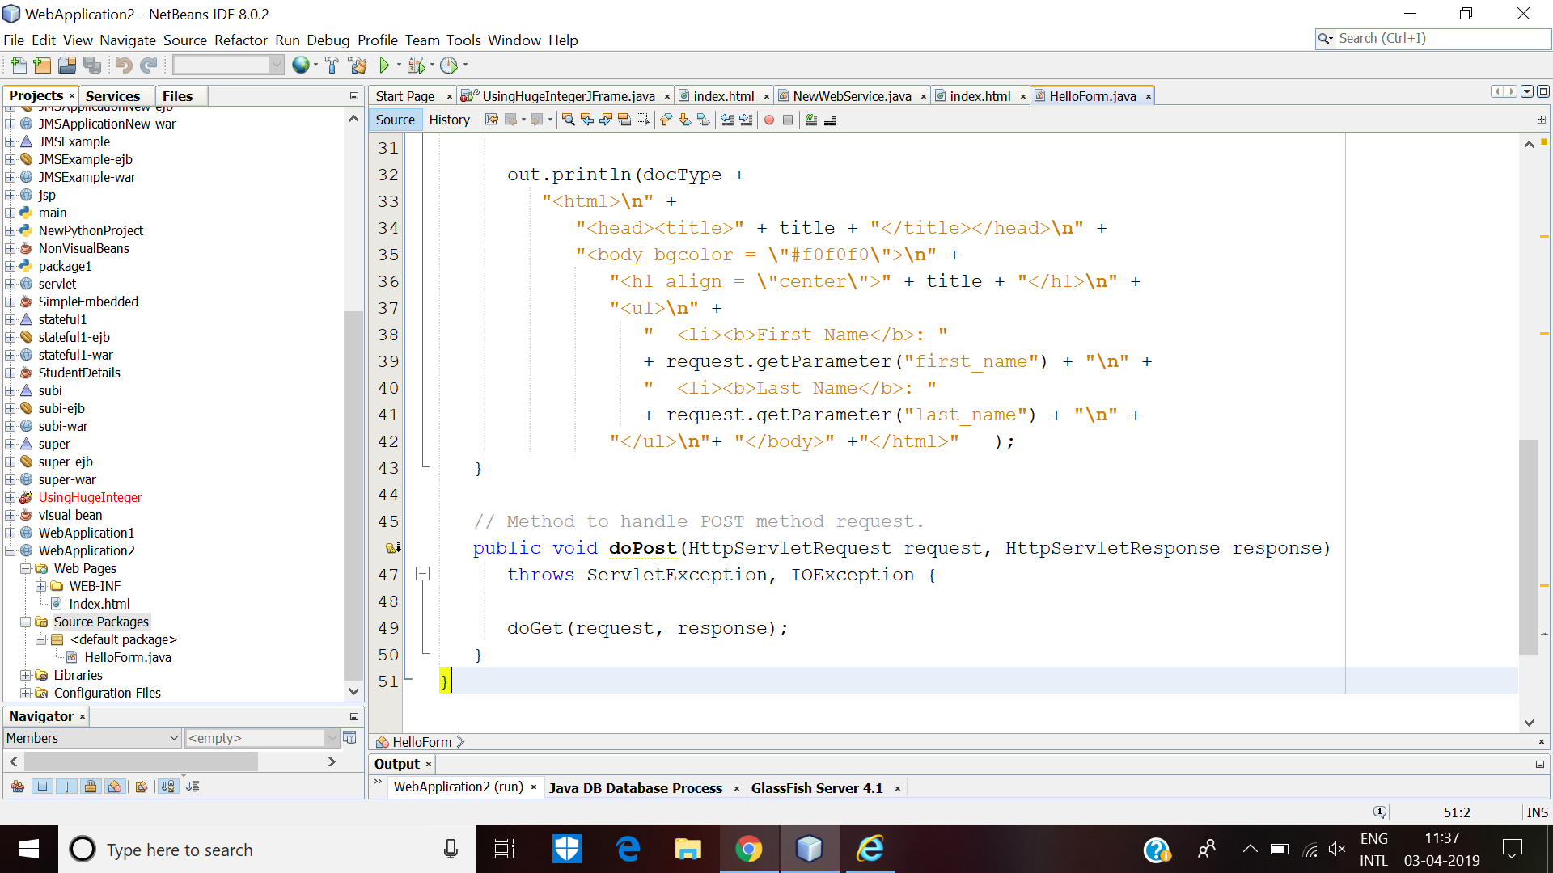

Screenshots

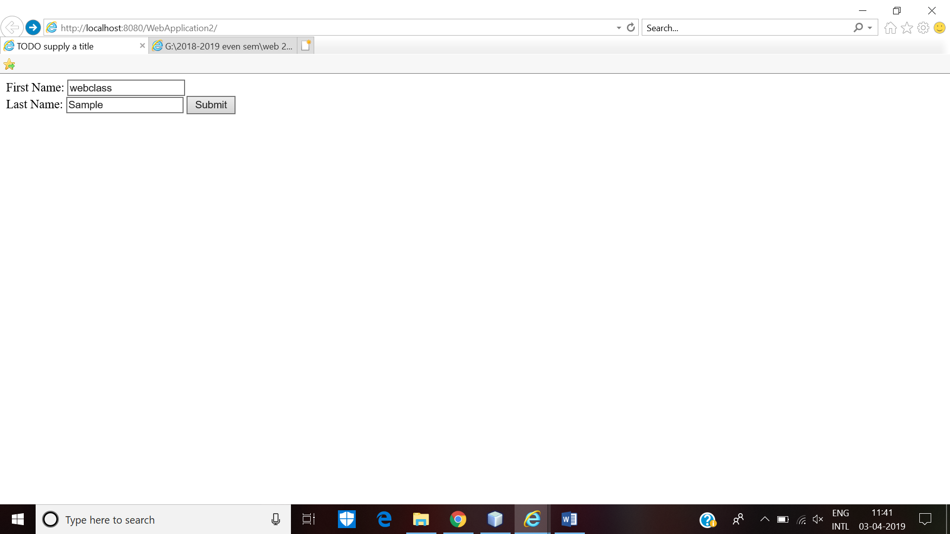

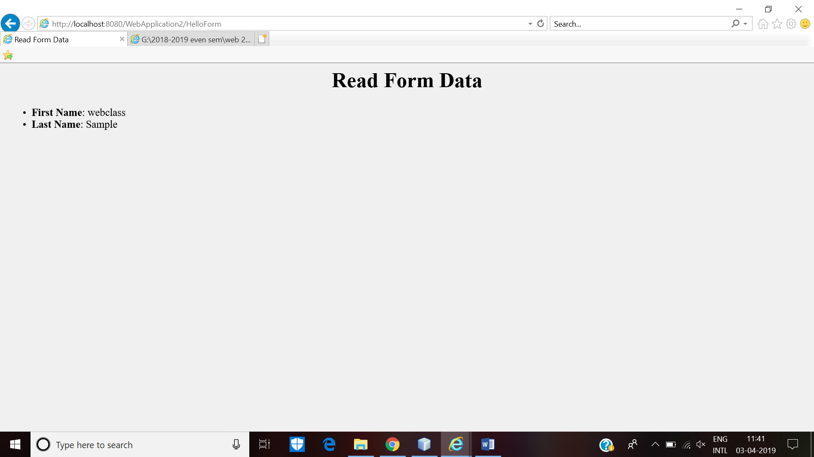

**JSP code:**

add.jsp

<%@ page language="java" contentType="text/html; charset=ISO-8859-1"

pageEncoding="ISO-8859-1"%>

<!DOCTYPE html PUBLIC "-//W3C//DTD HTML 4.01 Transitional//EN" "http://www.w3.org/TR/html4/loose.dtd">

<html>

<head>

<meta http-equiv="Content-Type" content="text/html; charset=ISO-8859-1">

<title>Sum two numbers</title>

</head>

<body>

<%= "<h1> The sum is "+(Integer.parseInt(request.getParameter("t1"))+Integer.parseInt(request.getParameter("t2")))+"</h1>"%>

</body>

</html>

sum.html

<html>

<head>

<title>Enter two numbers to add up</title>

</head>

<body>

<form action="add.jsp">

First number: <input type="text" name="t1"/>

Second number: <input type="text" name="t2"/>

<input type="submit" value="SUBMIT" />

</form>

</body>

